TERMS OF REFERENCE
for
TECHNICAL EXPERT (Electrical Engineer)
under
SERBIA SCALING UP RESIDENTIAL CLEAN ENRGY (SURCE) PROJECT

Background

The Government of the Republic of Serbia (GoS) has secured financing from the International Bank for Reconstruction and Development (IBRD), which is part of the World Bank Group, to implement the Serbia ‘Scaling Up Residential Clean Energy’ (SURCE) Project, hereinafter “The Project”. The development objective of the Project is to increase the uptake of energy efficiency, sustainable heating, and rooftop solar photovoltaics (RSPV) by households in participating local self-government units (LSGUs) in Serbia. An important associated objective is to reduce greenhouse gas (GHG) emissions and improve air quality thanks to achieved energy savings and reduced use of solid fuels for heating. These objectives will be achieved by two project components:
- Component 1: Financing Energy Efficiency, Sustainable Heating, and Rooftop Solar Investments in Residential Buildings with a key focus on single-family houses (SFHs).
- Component 2: Technical Assistance and Implementation Support, with the overall aim of supporting the development of scalable financing mechanisms and removing market barriers, with three subcomponents: (a) enhancing local market capacity, improving enabling environment, and strengthening public awareness; (b) technical studies informing program design and implementation; and (c) project implementation support.

Components 1 and 2 will be implemented simultaneously; together they represent USD 50 million with Component 1 being allocated the major share of loan proceeds. Investments will be financed under Component 1 and scaled up relying on the analytical insights, institutional structures, and financing mechanisms developed under Component 2. The Ministry of Mining and Energy (MoME) might provide additional funds from the government budget to expand the scope of the investments.

The Project became effective in December 2022 and will be implemented over a 5-year period until November 2027. The overall responsibility for implementation of the project rests with the Government of Serbia, with the MoME acting as implementing entity. The MoME will establish a Project Implementation Unit (PIU) to carry out the day-to-day activities of Project implementation. The PIU will coordinate closely with the MoME as well as the World Bank energy team responsible for the Project implementation on IBRD side.

The Project will scale up a revised version of an existing government program, piloted in 2021, financing residential EE investments through a combination of public grants and leveraged private-sector financing. The investments under Component 1 will be financed through: (a) partial grants financed through the Project, offered by the MoME and channeled through participating local self-governing units (LSGUs); (b) partial grants offered by the LSGUs directly, in parallel with the IBRD financing channeled through the Project; and (c) household contributions, financed either from savings or borrowings (Figure 1).

Figure 1. Structure of the Project, with the LSGU playing a pivotal role and the citizen required to pay a share of the investment

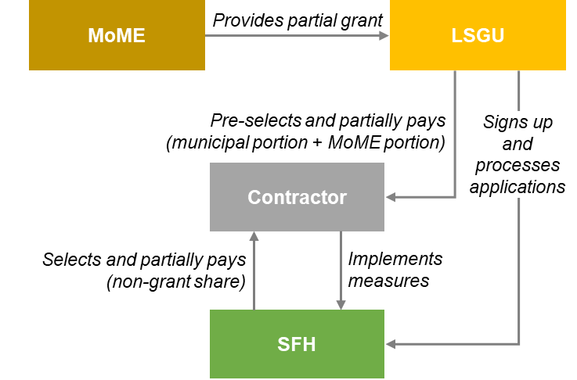

Notes: MoME: Ministry of Mining and Energy; SFH: single-family house; LSGU: Local self-government unit.
Source: World Bank staff.
The MoME intends to engage a consultant to take on the assignment presented in the ToR. The ToR also define the scope of responsibilities of the prospective Technical Expert (Electrical Engineer) (“Consultant”). A part of the proceeds of the IBRD loan will be used for financing the proposed consultancy assignment...

Objective of the assignment

The objective of this assignment is to lead and coordinate engineering and technical aspects of the activities implemented under the Project.

Scope of Work

The role of the Consultant will be to monitor the technical and engineering aspects of interventions under the Project, including building retrofits and other related services. The Consultant will assist the PIU Head in implementation of the Project (including team management, coordination of activities, and communication with stakeholders) in collaboration with other PIUs experts, LSGUs, the World Bank team and consulting firms, which will be hired by the PIU for a series of associated activities (eg, outreach, IT tools, monitoring and evaluation).

The Consultant main tasks will be to provide technical direction, guidance and support to enable scale up of investments under the Project, while complying with the parameters the project has defined for the designs, technical specifications and implementation quality of clean energy measures at SFH level. The Consultant will also contribute to the standardization of approaches across LSGUs to increase the efficiency of program roll-out and contribute to the completion of works within approved budget and time to the satisfaction of the building owner, the LSGU, MoME and the World Bank.

The activities to be performed by the Consultant include but are not limited to the following:
- Assist the Senior Engineer in providing technical support to LSGUs (i) to follow Project implementation procedures; (ii) to verify eligible sub-projects consisting of rooftop solar PV (RSPV) instalation; (iii) to monitor implementation of the project with a focus on technical aspects; and (iv) verify energy savings of implemented sub-project contracts on a sample basis.
- Consult with local and international technical experts on implementation progress and coordinate on specific energy efficiency and sustainable energy issues.
- Assist the Senior Engineer in monitoring compliance with implementation arrangements, including assessment of status of civil works contracts, timely commencement and completion of works.
- Monitoring of the qualification and selection process of supply contractors including the provision of evidence for quality of materials and equipment (certificates, laboratory reports, etc).
- Monitor compliance with pre-qualified materials and equipment included in project specifications.
- Assist the Senior Engineer to develop site inspection and monitoring routines related to rooftop solar PV (RSPV) instalation for completed sub-projects and assist LSGU experts in implementing these routines where needed.
- From time to time, spot-check of building sub-project sites in order to validate that supply and installation of equipment and materials are in compliance with all conditions and requirements, stipulated in contracts, and they comply with the specification’s requirements and the rulebook. This may comprise visual check of quality / dimensions of material and equipment. Establish for cases of discrepancy a protocol for testing of goods/equipment and its requalification.
- Establish efficient procedures for verifying contractor performance and reporting progress, including timely and quality control reports, and quantity survey records.
- Assist the Senior Engineer to monitor and analyze the program-level impact of buildings retrofits, review monitoring reports of LSGUs, and check compliance with projected energy and GHG emissions savings. Monitoring the level of energy savings and reduction of CO2 emissions achieved by rooftop solar PV (RSPV) instalation, as well as their share in the entire Project.

- Support the IT expert of the PIU to develop and maintain consistency within the project database and program management tools in areas related to (i) technical aspects, such as calculation of energy & emission savings, and (ii) benchmark unit costs for selected equipment and material for building retrofit.
- Lead the development of technical guidelines to guide SFH household applicants, LSGUs and contractors.
- Assist on technical aspects of program implementation, including future calls for registration of qualified supply contractors. This may comprise assistance in the update of rulebooks, technical specification and installation guidelines for contractors.
- Contribute to capacity building activities, such as training events, provided by the PIU to LSGUs and contractors.
- Participate in public events organized by the program and public awareness activities when need for technical input is identified.
- Contribute to periodic program implementation progress reports for submission to MoME and World Bank in accordance with the Project Operation and Grant Manual (POGM), by monitoring and evaluation of technical performance indicators for the project and providing technical information.
- Perform other tasks suited for the qualifications of an engineer, as requested by the PIU Head.

Expected Outputs

Technical inputs for quarterly project management reports, twice-annual progress reports, annual budget and work plans, and mid-term review documentation. Day-to-day management of the technical aspects of the Project, and preparation of ad hoc technical reports and papers as the needs of the Project require.

Reporting

The Consultant will report to the Head of the PIU under the MoME.

Assignment duration

The Consultant shall provide full-time services for the life of the Project, i.e. until November 30, 2027, with a probationary period of six (6) months. The consultant hired for a full-time position under Bank project is not allowed, at the same time, to hold another full time or part time assignment.

Qualification Requirements

The Consultant should possess the following knowledge and work experience:

Education:

- University degree in Electrical Engineering or relevant technical studies with at least 240 ECTS points or equivalent (Bachelor Academic Studies, in the scope of at least 240 ECTS points, Master Academic Studies, Specialist Academic Studies, Specialist Vocational Studies, i.e. at Bachelor studies lasting at least four years or Specialist Academic Studies at the University).

Experiences:

At least 5 years of working experience in the construction of electrical systems and installation of the equipment.

Language:

- Fluency in Serbian and working knowledge of both spoken and written English language.

Expertise and experience in the following fields is considered as an asset:
- At least 2 years of work experience in buildings energy efficiency retrofitting;
- Possession of a license that covers the areas of rooftop solar PV (RSPV) installation/design (label 350 and/or 450 or similar - issued by engineer’s chamber of Serbia)
- Experience with contractors, either in design, works, writing of specifications, bills of quantities, tender procedures or site works supervision;
- Computer skills (Microsoft Office).
- Experience in designing and installation of solar panels;
- Knowledge of standards related to design/installation/commissioning of building electric installations and standards related to building energy performance and efficiency;
- Experience in preparation of analytical materials and reports;
- Capacity building and training to stakeholders.

Input by the MoME

The MoME will provide the Consultant with complete office infrastructure, the required equipment, access to any documentation and information necessary for the performance of his / her tasks.

Procurement Regulation

The attention of interested Consultants is drawn to paragraph 3.14, 3.16 and 3.17 of the World Bank’s Procurement Regulations for Investment Project Financing (IPF) Borrowers, Procurement in Investment Project Financing Goods, Works, Non-Consulting, and Consulting Services (updated November 2020) setting forth the World Bank’s policy on conflict of interest.

Selection of consultant

A Consultant will be selected in accordance with the Open Competitive Selection of Individual Consultants as set out in the World Bank’s Procurement Regulations. The type of contract will be time-based contract.

The candidates will be evaluated applying the following evaluation criteria:
- General experience (40 Points)
- Specific experience and skills relevant to the assignment (60 Points)

